JECRC

JAIPUR

INDIVIDUAL FACULTY DATA SHEET 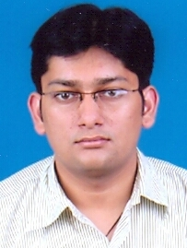
Name of the faculty member | : | HONEY AGARWAL
Present Designation | : | Assistant Professor
Email Id: honeyagarwal.ece@jecrc.ac.in
Contact Details: 9887231368

I. Particulars of Educational Qualification: (only completed)

Category | Name of the Degree | Specialization | Year of Passing | Name of the College | Name of the University
UG | B.E(Hons) | ECE | 2008 | JECRC | Rajasthan University
PG | M.Tech | ECE | 2013 | - | Jagannath University
Ph.D.

II. Academic Experience : 7 years

III. Industrial Experience : -

IV. Title of Ph.D. Thesis : -

V. Awards/Achievements : In M.Tech got 3rd rank in university.

Did my B.E in Honors.

VI. Research/Specialization : -

VII. Course Taught : Digital Logic Design , Embedded System Design, CAD for VLSI

VIII. Refereed International Journal Publication : -

IX. International Conference Proceeding : -

X. Books Written : -

XI. M.Tech Thesis Guide : -

XII. PHD Thesis Guide : -

XIII. Professional Body Membership : -

